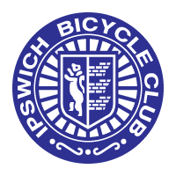
IPSWICH BICYCLE CLUB
https://ipswichbicycleclub.co.uk/
Open 10 Mile Time Trial
Promoted for and on behalf of Cycle Time Trials under their Rules & Regulations on
Saturday 27th May (14:00)
Crowfield Circuit (CTT Course No. B10/32) course
Officials
Time keeping: Mr Angus Jardine and Mr Mark Salter
Thanks to Marshals: Clive Tricker, Tracey McKenzie, Ashley Nixon, Chris Thornelow, Claire for refreshments
Event Secretary: Jon Carlyon
123 Parliament Rd, IPSWICH, Suffolk, IP45EP
carljonath@aol.com 07910 802047

Prizes were given one per rider, excluding team, to the highest domination won.
Scratch
1st Samuel Asker £30
2nd David Halliday £20
3rd Peter Hurry £10
Fastest Lady: Becky Ridge £30
Vet on Standard
1st Matt O’Brian £30
2nd Julian Bosley £20
3rd Glen Taylor £10
Team: Loose Cannon’s conditioning (72.25) Matt O’Brian, Becky Ridge, Thomas Hudson (£10 per rider).

